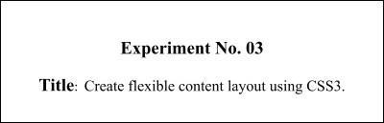

**Batch: B-4 Roll No.: 16010422234 Name: Chandana Ramesh Galgali**

**Experiment No.: 3**

**Aim:** To apply basic CSS and flexible content layout using CSS3 to your website.

**_____________________________________________________________________________**

**Resources needed:** Visual Studio Code(or any other IDE), any web browser

**_____________________________________________________________________________**

**Theory:**

**Cascading Style Sheets** (**CSS**) is a style sheet language used for describing the presentation of a document written in a markup language. HTML was NEVER intended to contain tags for formatting a web page. HTML was created to **describe the content** of a web page. CSS is designed primarily to enable the separation of document content from document presentation, including aspects such as the layout, colors, and fonts. This separation can improve content accessibility, provide more flexibility and control in the specification of presentation characteristics, enable multiple HTML pages to share formatting by specifying the relevant CSS in a separate .css file, and reduce complexity and repetition in the structural content. The file should not contain any html tags. The style sheet file must be saved with a .css extension.

CSS has various levels and profiles like CSS1, CSS2, CSS3, CSS4. There are three ways of inserting a style sheet:

* External style sheet
* Internal style sheet
* Inline style

**External Style Sheet**

Each page must include a reference to the external style sheet file inside the <link> element. The <link> element goes inside the <head> section of the html page. An external style sheet is ideal when the style is applied to many pages.

**Internal Style Sheet**

An internal style sheet may be used if one single page has a unique style. Internal styles are defined within the <style> element, inside the <head> section of an HTML page.

**Inline Styles**

An inline style may be used to apply a unique style for a single element. To use inline styles, add the style attribute to the relevant element. The style attribute can contain any CSS property.

**CSS Rule-Set**

A CSS rule-set consists of a selector and a declaration block:

Eg:

p {

text-align: center;

color: red;

}

Here p stands for paragraph element.

**CSS Colors and Backgrounds**

Colors can be applied by using colors and background-color. Colors are displayed combining RED, GREEN, and BLUE light. The CSS background properties are used to define the background effects for elements.

**CSS Margin and Padding Properties**

The CSS margin properties are used to generate space around elements. Margin is the space outside something whereas padding is the space inside something. The margin properties set the size of the white space OUTSIDE the border. The CSS padding properties are used to generate space around content.The padding properties set the size of the white space between the element content and the element border.

**CSS Dimension Properties**

The CSS dimension properties allow you to control the height and width of an element.

**Navigation Bars**

Having easy-to-use navigation is important for any web site. With CSS you can transform boring HTML menus into good-looking navigation bars.

**CSS Flexbox Layout**

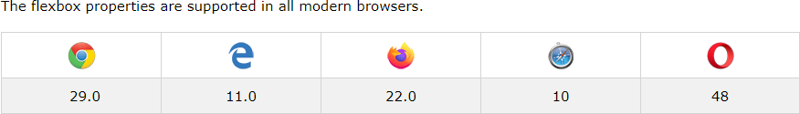

The Flexible Box Layout Module makes it easier to design flexible responsive layout structures 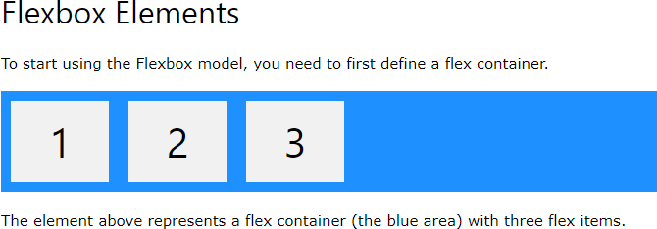without using float or positioning.

Example

<!DOCTYPE html>

<html>

<head>

<style>

.flex-container { display: flex;

background-color: DodgerBlue;

}

.flex-container > div { background-color: #f1f1f1; margin: 10px;

padding: 20px; font-size: 30px;

}

</style>

</head>

<body>

<div class="flex-container">

<div>1</div>

<div>2</div>

<div>3</div>

</div>

<p>A Flexible Layout must have a parent element with the <em>display</em> property set to <em>flex</em>.</p>

<p>Direct child elements(s) of the flexible container automatically becomes flexible items.</p>

</body>

</html>

**Output**

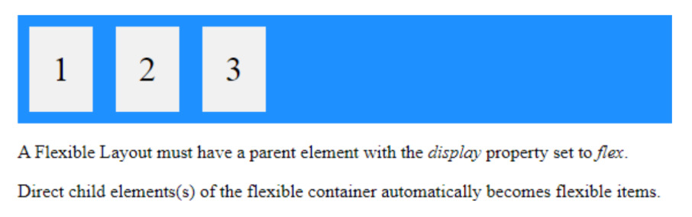

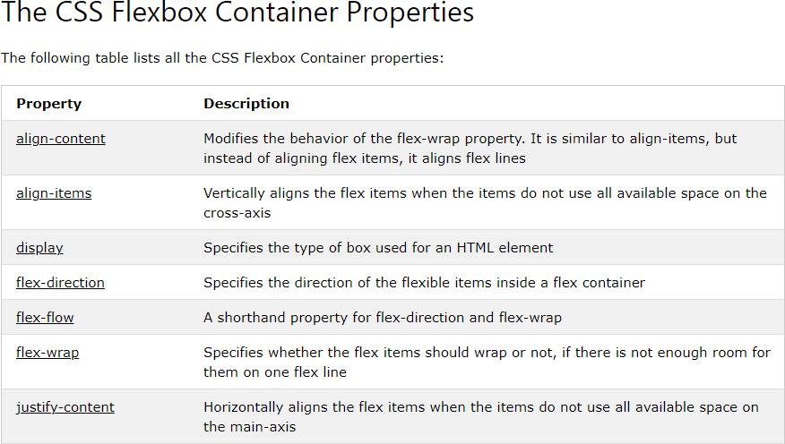

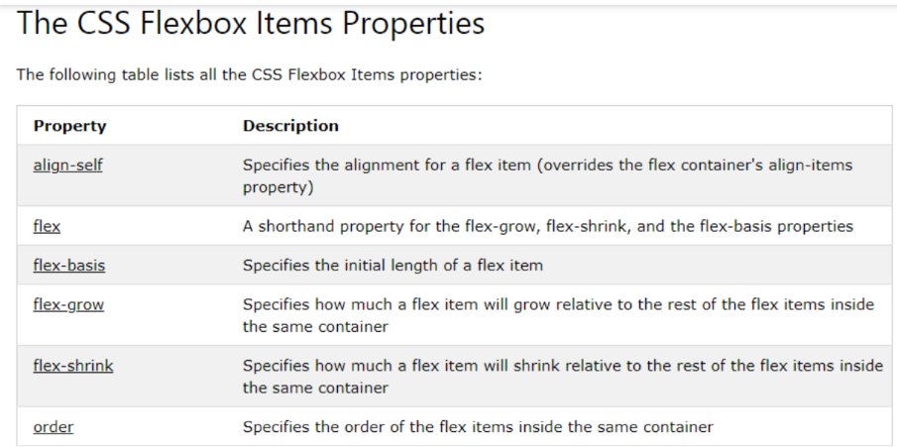

**Responsive Flexbox**

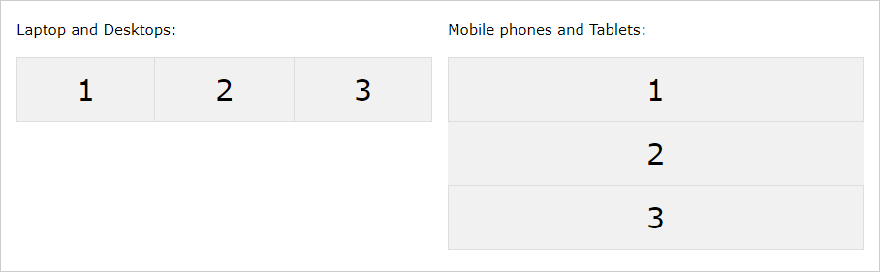

For example, if you want to create a two-column layout for most screen sizes, and a one- column layout for small screen sizes (such as phones and tablets), you can change the flex- direction from row to column at a specific breakpoint (800px in the example below.

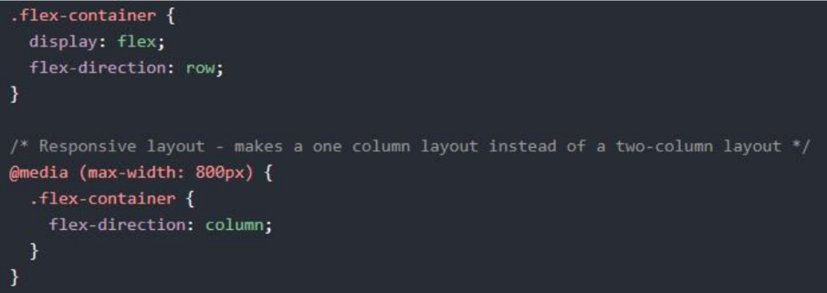

**CSS Grid Layout Module**

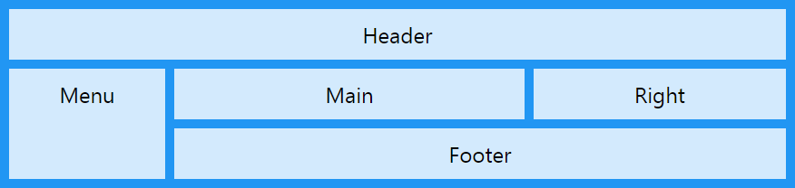

The CSS Grid Layout Module offers a grid-based layout system, with rows and columns, making it easier to design web pages without having to use floats and positioning.

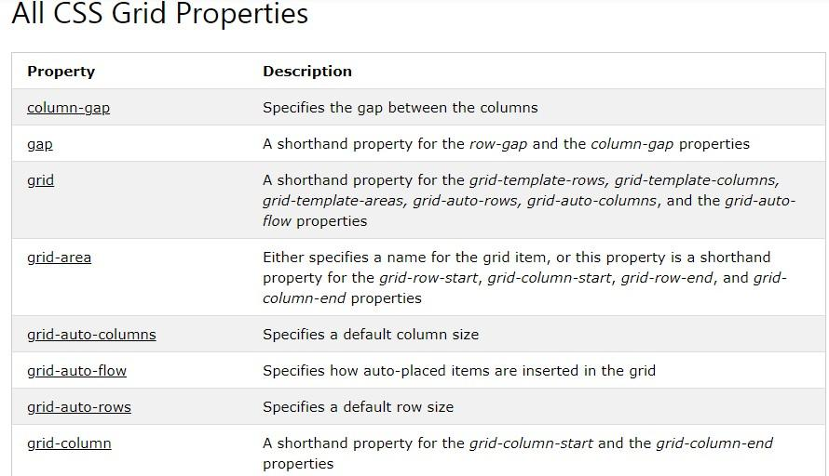

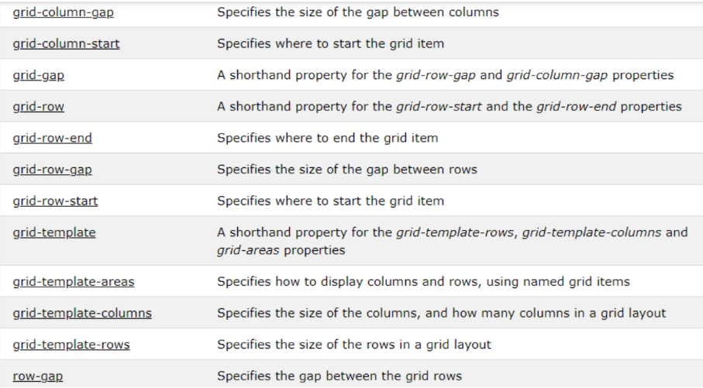

**Grid Container**

To make an HTML element behave as a grid container, you have to set the display property to grid or inline-grid.

Grid containers consist of grid items, placed inside columns and rows.

A grid container contains grid items.

By default, a container has one grid item for each column, in each row, but you can style the grid items so that they will span multiple columns and/or rows.

**_____________________________________________________________________________**

**Activity:**

Design a website pages using CSS properties like Colors and Background-color, Lengths and percentages, Margin and padding, Borders, Navigation bars, flexbox layout, flexbox container and item properties, responsive flexbox, CSS Grid, Grid Container, A grid container contains grid items.

**_____________________________________________________________________________**

**Results: (Display the designed web pages along with the code)**

**<!DOCTYPE html>**

**<html lang="en">**

**<head>**

**<meta charset="UTF-8">**

**<meta name="viewport" content="width=device-width, initial-scale=1.0">**

**<link rel="stylesheet" href="https://fonts.google.com/specimen/Playfair+Display">**

**<link rel="stylesheet" href="https://fonts.google.com/specimen/Playfair+Display">**

**<link rel="stylesheet" href="style.css">**

**<title>Blog</title>**

**</head>**

**<body>**

**<header>**

**<video id="video-background" autoplay loop muted>**

**<source src="C:\Users\chand\Downloads\IV SEM\WP-1\media\Perfume_commercial.mp4" type="video/mp4">**

**</video>**

**<font size="6" color="white" align="center">Scent Haven**

**<nav><p>**

**<a href="C:\Users\chand\Downloads\IV SEM\WP-1\EXP-3\exp3.html">Home</a> |**

**<a href="C:\Users\chand\Downloads\IV SEM\WP-1\EXP-3\exp3b.html">Shop</a> |**

**<a href="C:\Users\chand\Downloads\IV SEM\WP-1\EXP-3\exp3c.html">About Us</a> |**

**<a href="#samepage">Blog</a> |**

**<a href="mailto:chandana.galgali@gmail.com">Contact</a></p></font>**

**</nav>**

**</header>**

**<div class="blog-container">**

**<div class="blog-post">**

**<h2>"The Art of Perfumery" : Unraveling the Craft</h2>**

**<img src="C:\Users\chand\Downloads\IV SEM\WP-1\media\blog1.jpg">**

**<p>In this blog post, delve into the intricate world of perfumery. Explore the art and science behind creating captivating fragrances. Discuss the various fragrance notes, extraction methods, and the role of a perfumer's expertise. Share insights into how Scent Haven's master perfumers blend creativity with tradition to craft unique and memorable scents.</p>**

**<a href="#">Read More</a>**

**</div>**

**<div class="blog-post">**

**<h2>"Scent and Emotion" : The Power of Fragrance in Eliciting Emotions</h2>**

**<img src="C:\Users\chand\Downloads\IV SEM\WP-1\media\blog2.jpg">**

**<p>Explore the profound connection between scent and emotions. Discuss how certain fragrances can evoke memories, uplift moods, or create a sense of calm. Highlight specific scents from Scent Haven's collection and describe the emotions they are designed to evoke. Share personal stories or anecdotes related to the emotional impact of fragrance.</p>**

**<a href="#">Read More</a>**

**</div>**

**<div class="blog-post">**

**<h2>"Sustainable Scent: A Fragrance Revolution" : Redefining Luxury with Eco-friendly Practices</h2>**

**<img src="C:\Users\chand\Downloads\IV SEM\WP-1\media\blog3.jpg">**

**<p>Address the growing importance of sustainability in the fragrance industry. Discuss Scent Haven's commitment to eco-friendly sourcing, cruelty-free testing, and recyclable packaging. Highlight specific initiatives and practices that set Scent Haven apart as a brand dedicated to environmental responsibility. Encourage readers to make conscious choices when selecting fragrances.</p>**

**<a href="#">Read More</a>**

**</div>**

**</div>**

**<div id="seasonal-recommendations" class="seasonal-recommendations">**

**<h2>Seasonal Fragrance Recommendations</h2>**

**<p>Discover scents that complement different seasons or occasions. Whether it's a vibrant spring, a warm summer, a cozy fall, or a festive winter - we have the perfect fragrance for every moment.</p>**

**<div class="slideshow-container">**

**<div class="fragrance-slide">**

**<img src="C:\Users\chand\Downloads\IV SEM\WP-1\media\spring.jpeg" alt="Spring Fragrance">**

**<h3>Spring Blossom</h3>**

**<p>A light and floral fragrance with notes of blooming flowers and fresh greens. Perfect for embracing the renewal of spring.</p>**

**</div>**

**<div class="fragrance-slide">**

**<img src="C:\Users\chand\Downloads\IV SEM\WP-1\media\summer.jpg" alt="Summer Fragrance">**

**<h3>Sun-kissed Citrus</h3>**

**<p>Capture the essence of summer with this citrusy delight. Refreshing notes of citrus fruits and sunshine for a bright and uplifting experience.</p>**

**</div>**

**<div class="fragrance-slide">**

**<img src="C:\Users\chand\Downloads\IV SEM\WP-1\media\fall.jpeg" alt="Fall Fragrance">**

**<h3>Autumn Spice</h3>**

**<p>Embrace the warmth of autumn with this spicy and comforting fragrance. Notes of cinnamon, vanilla, and amber create a cozy atmosphere.</p>**

**</div>**

**<div class="fragrance-slide">**

**<img src="C:\Users\chand\Downloads\IV SEM\WP-1\media\winter.jpg" alt="Winter Fragrance">**

**<h3>Frosty Pine</h3>**

**<p>Step into a winter wonderland with this enchanting fragrance. Crisp notes of pine, juniper, and a hint of vanilla evoke the magic of snowy landscapes.</p>**

**</div>**

**<a class="prev" onclick="plusSlides(-1)">&#10094;</a>**

**<a class="next" onclick="plusSlides(1)">&#10095;</a>**

**</div>**

**</div>**

**<script src="script.js"></script>**

**<hr>**

**<footer>**

**&copy; Scent Haven (since 2004)**

**</footer>**

**</body>**

**</html>**

**style.css**

**body {**

**font-family: 'Playfair Display', serif;**

**margin: 20px;**

**}**

**header {**

**font-family: 'Playfair Display', serif;**

**height: 250px;**

**width: 100%;**

**position: relative;**

**overflow: hidden;**

**display: flex;**

**align-items: center;**

**justify-content: space-around;**

**border-radius: 10px 10px 10px 10px;**

**}**

**#video-background {**

**opacity: 80%;**

**position: absolute;**

**top: 0;**

**left: 0;**

**width: 100%;**

**height: 100%;**

**object-fit: cover;**

**z-index: -1;**

**}**

**nav {**

**display: flex;**

**}**

**nav a {**

**text-decoration: none;**

**color: #FFFFFF;**

**margin-right: 20px;**

**margin-left: 20px;**

**}**

**nav a:hover {**

**color: #c45252;**

**}**

**h1, h2, h3 {**

**font-family: 'Playfair Display', serif;**

**color: #FFFFFF;**

**}**

**p {**

**font-family: 'Playfair Display', serif;**

**color: #FFFFFF;**

**}**

**img {**

**height: 300px;**

**width: 350px;**

**}**

**.blog-container {**

**display: grid;**

**grid-template-columns: repeat(3, 1fr);**

**gap: 20px;**

**padding: 20px;**

**}**

**.blog-post {**

**border: 1px solid #ddd;**

**border-radius: 8px;**

**background-color: #3f393f;**

**padding: 20px;**

**}**

**@media (max-width: 768px) {**

**.blog-container {**

**grid-template-columns: 1fr;**

**}**

**}**

**@media only screen and (max-width: 600px) {**

**.container, .grid-container {**

**grid-template-columns: 1fr;**

**}**

**.slideshow-container,**

**.flex-container {**

**width: 100%;**

**}**

**}**

**script.js**

**let slideIndex = 1;**

**function showSlides(n) {**

**let i;**

**const slides = document.getElementsByClassName("fragrance-slide");**

**if (n > slides.length) { slideIndex = 1 }**

**if (n < 1) { slideIndex = slides.length }**

**for (i = 0; i < slides.length; i++) {**

**slides[i].style.display = "none";**

**}**

**slides[slideIndex - 1].style.display = "block";**

**}**

**function plusSlides(n) {**

**showSlides(slideIndex += n);**

**}**

**showSlides(slideIndex);**

**Webpage:**

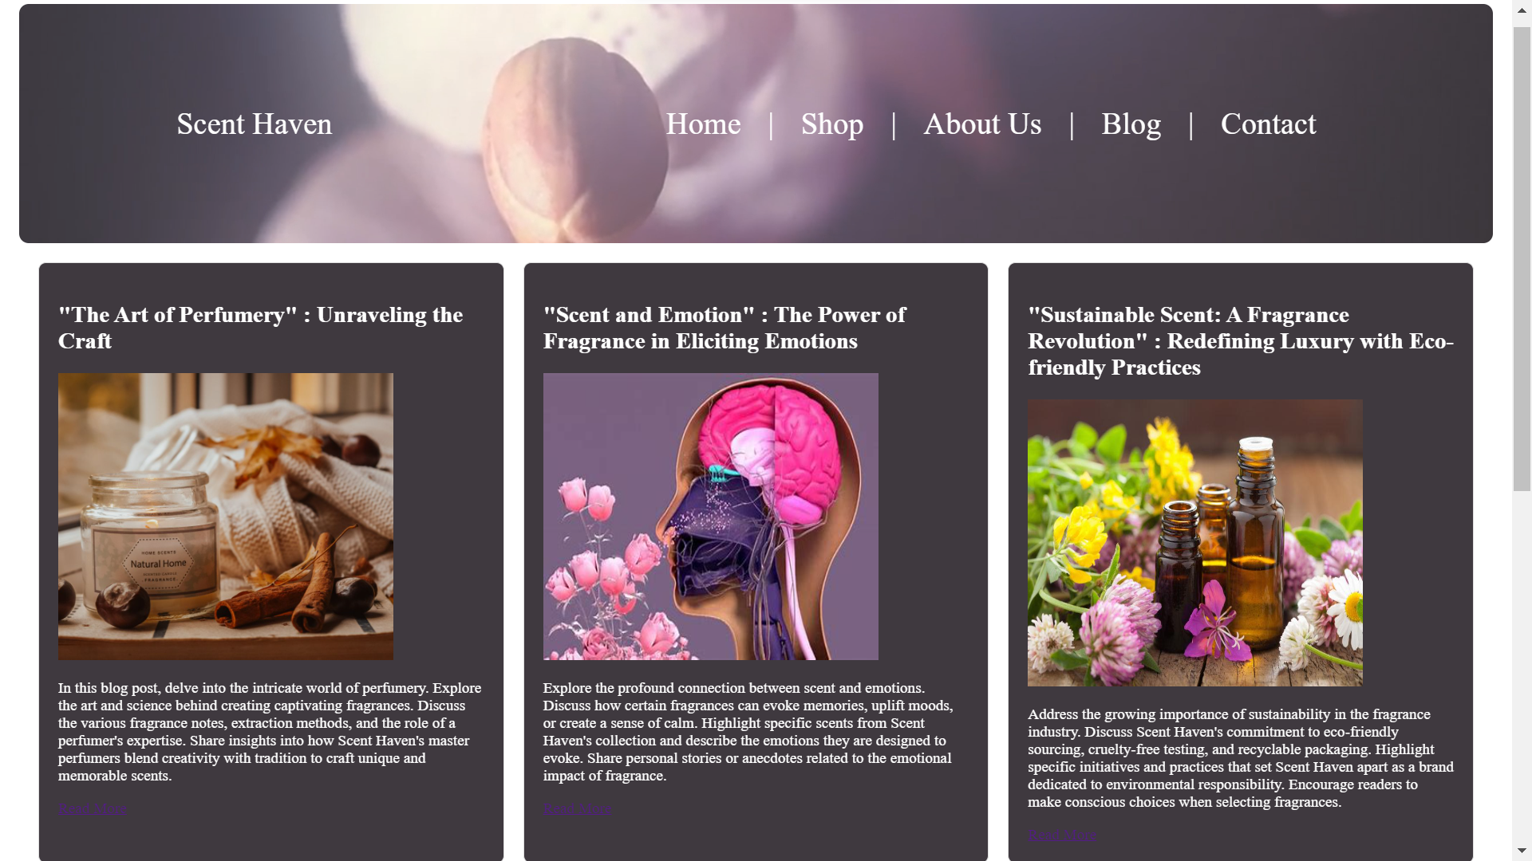

**_____________________________________________________________________________**

**Outcomes: Create Web pages using HTML 5 and CSS**

**_____________________________________________________________________________**

**Questions:**

**1. How many axes does a flex - box layout contain?**

**Ans:** A flexbox layout contains only one axis. It can be either the main axis or the cross axis. The main axis is defined by the flex-direction property, and the cross axis is perpendicular to it.

**2. What is the difference between auto - fill and auto - fit properties when defining a grid - template?**

**Ans:** Both auto-fill and auto-fit are values for the grid-template-columns and grid-template-rows properties in a grid layout.

auto-fill: This property creates as many columns or rows as possible without overflowing the container. It will create empty tracks if there is not enough content to fill all the tracks.

auto-fit: Similar to auto-fill, it also creates as many tracks as possible, but it will not create empty tracks. If there is not enough content to fill all the tracks, it will automatically adjust the size of the tracks to fill the available space.

**3. What is the meaning of the fr unit in the grid layout?**

**Ans:** In a grid layout, the fr unit stands for "fractional unit" or "fraction of available space." It is used to distribute the available space in the grid container among the columns or rows. For example, if you have three columns with 1fr 2fr 1fr, it means that the available space will be divided into four parts, and the middle column will take up twice as much space as the other two. It's a flexible way to create layouts that adapt to the available space.

**_____________________________________________________________________________**

**Conclusion: (Conclusion to be based on the outcomes achieved)**

The experiment has successfully integrated basic CSS and flexible content layout using CSS3 into the website, resulting in an aesthetically pleasing, responsive, and user-friendly web presence. The outcomes achieved underscore the importance of leveraging modern web design techniques to enhance both the visual appeal and functionality of websites in today's digital landscape.

**_____________________________________________________________________________**

**Grade: AA / AB / BB / BC / CC / CD /DD**

**Signature of faculty in-charge with date**

**_____________________________________________________________________________**

**References:**

**Books/ Journals/ Websites:**

* + "HTML5: Black Book", Dreamtech Publication.
  + "Web Technologies: Black Book", Dreamtech Publication.
  + [http://www.w3schools.com](http://www.w3schools.com/).